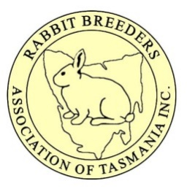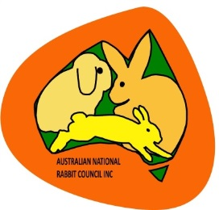
Australian National Rabbit Council Inc. Extravaganza 2016
Auction Registration Form:
Name:
Stud:
Member of which Club / Clubs:
Contact Number:
Address:
Will you be present at the auction? YES / NO
If you are not intending to be present at the auction you can bid one of two ways:
- You may have an agent bid on your behalf. Details of whom are to be filled out on this form Or,
- You may nominate a maximum bid in writing, on this form, 48 hours prior to the event. Please note that should you submit a maximum bid, and you are the successful bidder your nominated amount will be what you are charged for your purchase.
If using an agent please fill out the information below:
Nominated Agents Name:
Agents Contact Number:
If bidding via the submission of a “maximum bid” please fill out the information below:
I,………………………………………………. Wish to submit a maximum bid of $................. for ……………………………………………. Being a rabbit in the 2016 ANRCI National Rabbit Extravaganza Auction.
I have read ALL the published Auction / Bidding requirement’s and understand that payments are to be made the day of the auction and proof of payment supplied. I understand that should I be successful in my bidding said rabbit will not be released to me for transportation until such time as payments have cleared. I understand that transport is at my own cost and to be arranged as a matter of priority.

Signed Date:

